Ideation Phase
Empathize & Discover

Date | 26 February 2026
Team ID | LTVIP2026TMIDS74388
Project Name | LAPTOP REQUEST CATALOG ITEM
Maximum Marks | 4 Marks

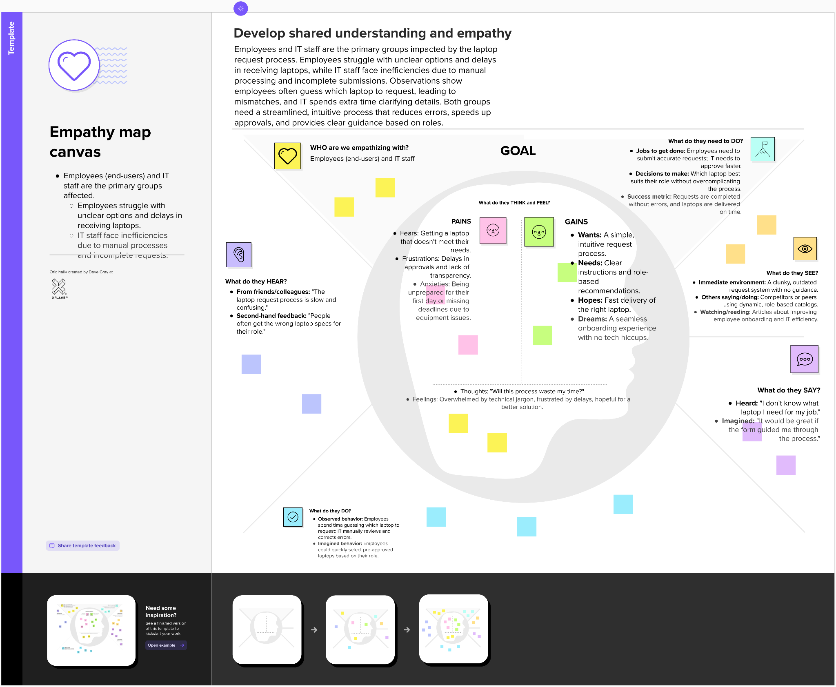
Empathy Map Canvas:

